🧪 Experiment:12 : Control LED using ESP32 and Blynk

🎯 Aim
To control an LED connected to ESP32 (GPIO 2) using the Blynk mobile application.

🧰 Requirements
- ESP32
- LED
- 220Ω resistor
- Mobile phone with Blynk app
- WiFi connection

⚙️ Procedure
Step 1: Wiring
- Connect LED positive terminal to GPIO 2 (D2)
- Connect LED negative terminal to GND through 220Ω resistor

Step 2: Install and Setup Blynk
- Install Blynk IoT app
- Create account and login
- Click New Template
  - Template Name: LED Control
  - Hardware: ESP32
  - Connection Type: WiFi
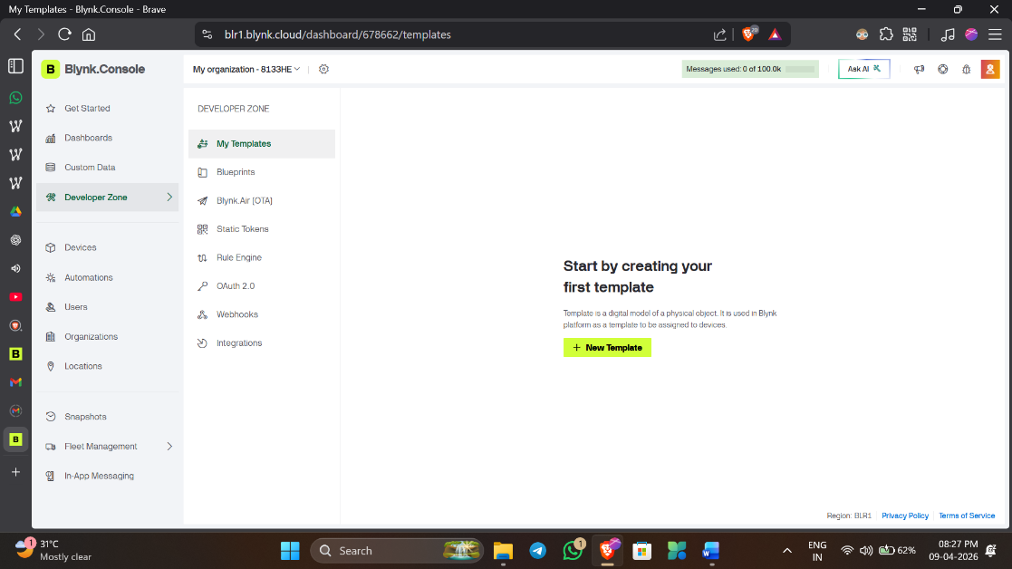
  - 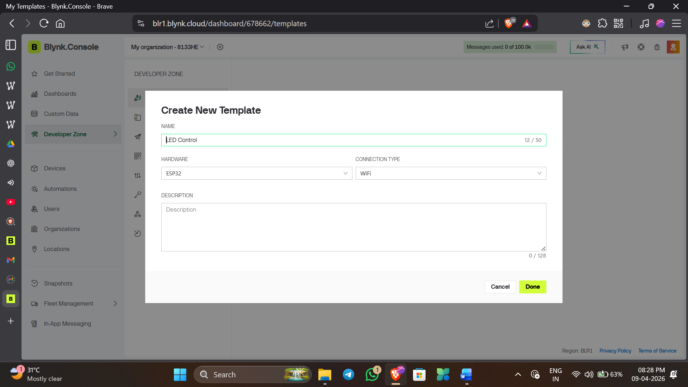
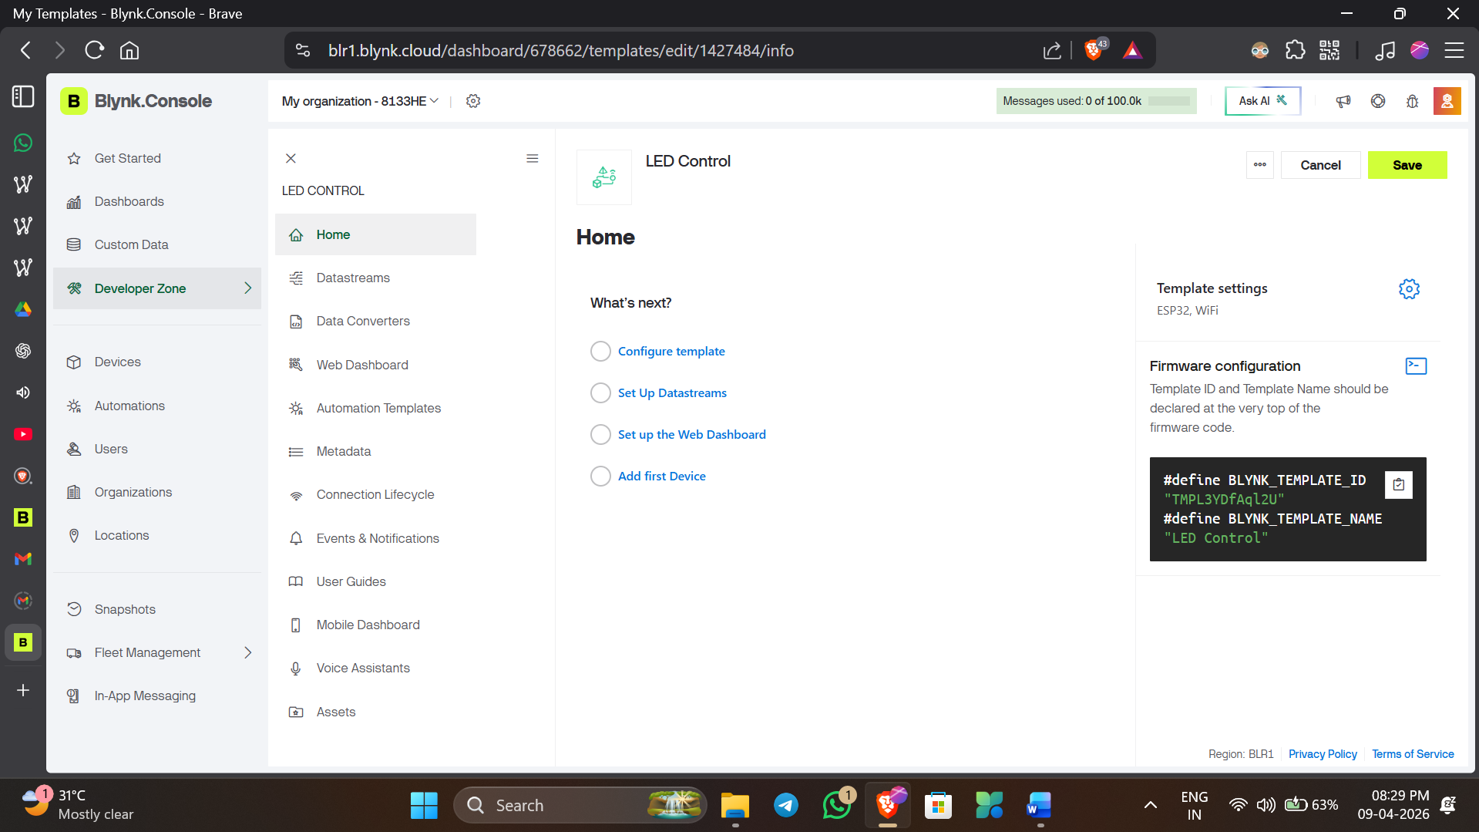

Step 3: Get Authentication Token
- Open template
- Go to Device Info
- Copy the Auth Token

Step 4: Create Datastream
- Create a new datastream
  - Name: LED
  - Virtual Pin: V0
  - Data Type: Integer 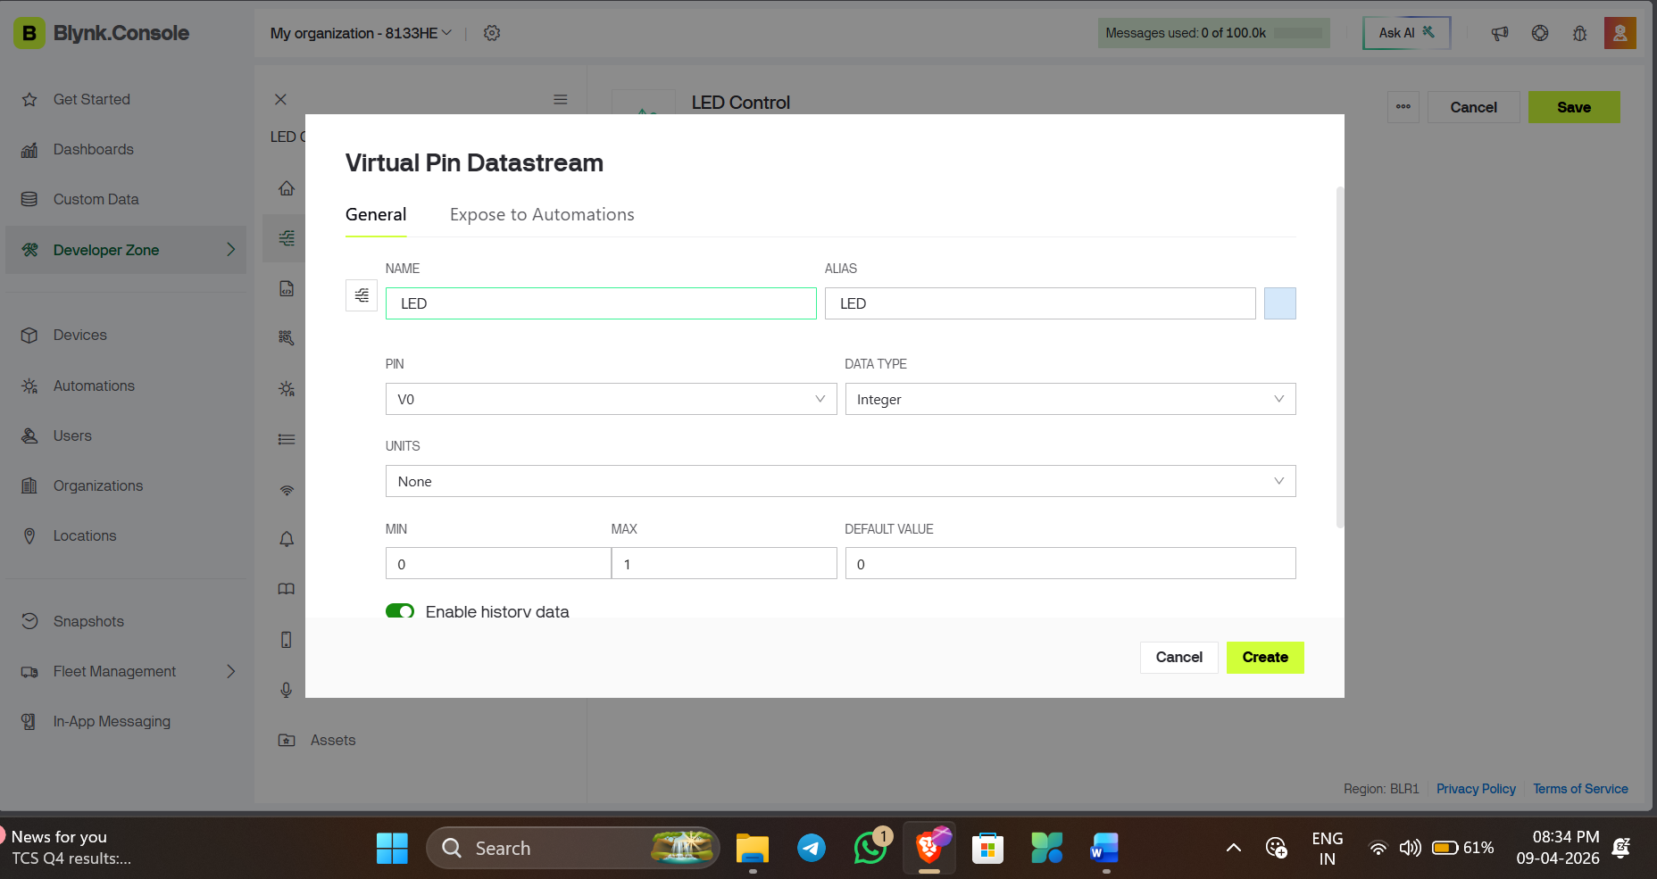

Step 5: Add Button Widget
- Choose Devices from dashboard and select “From Template”
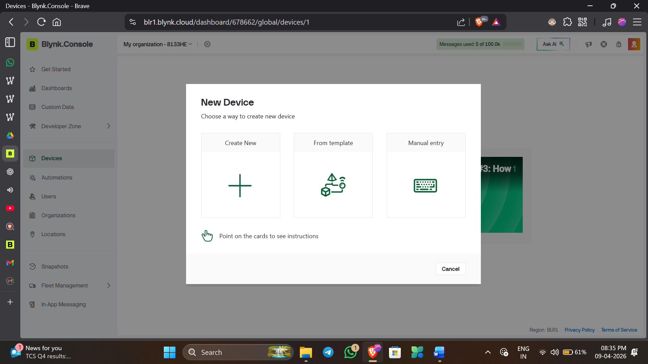
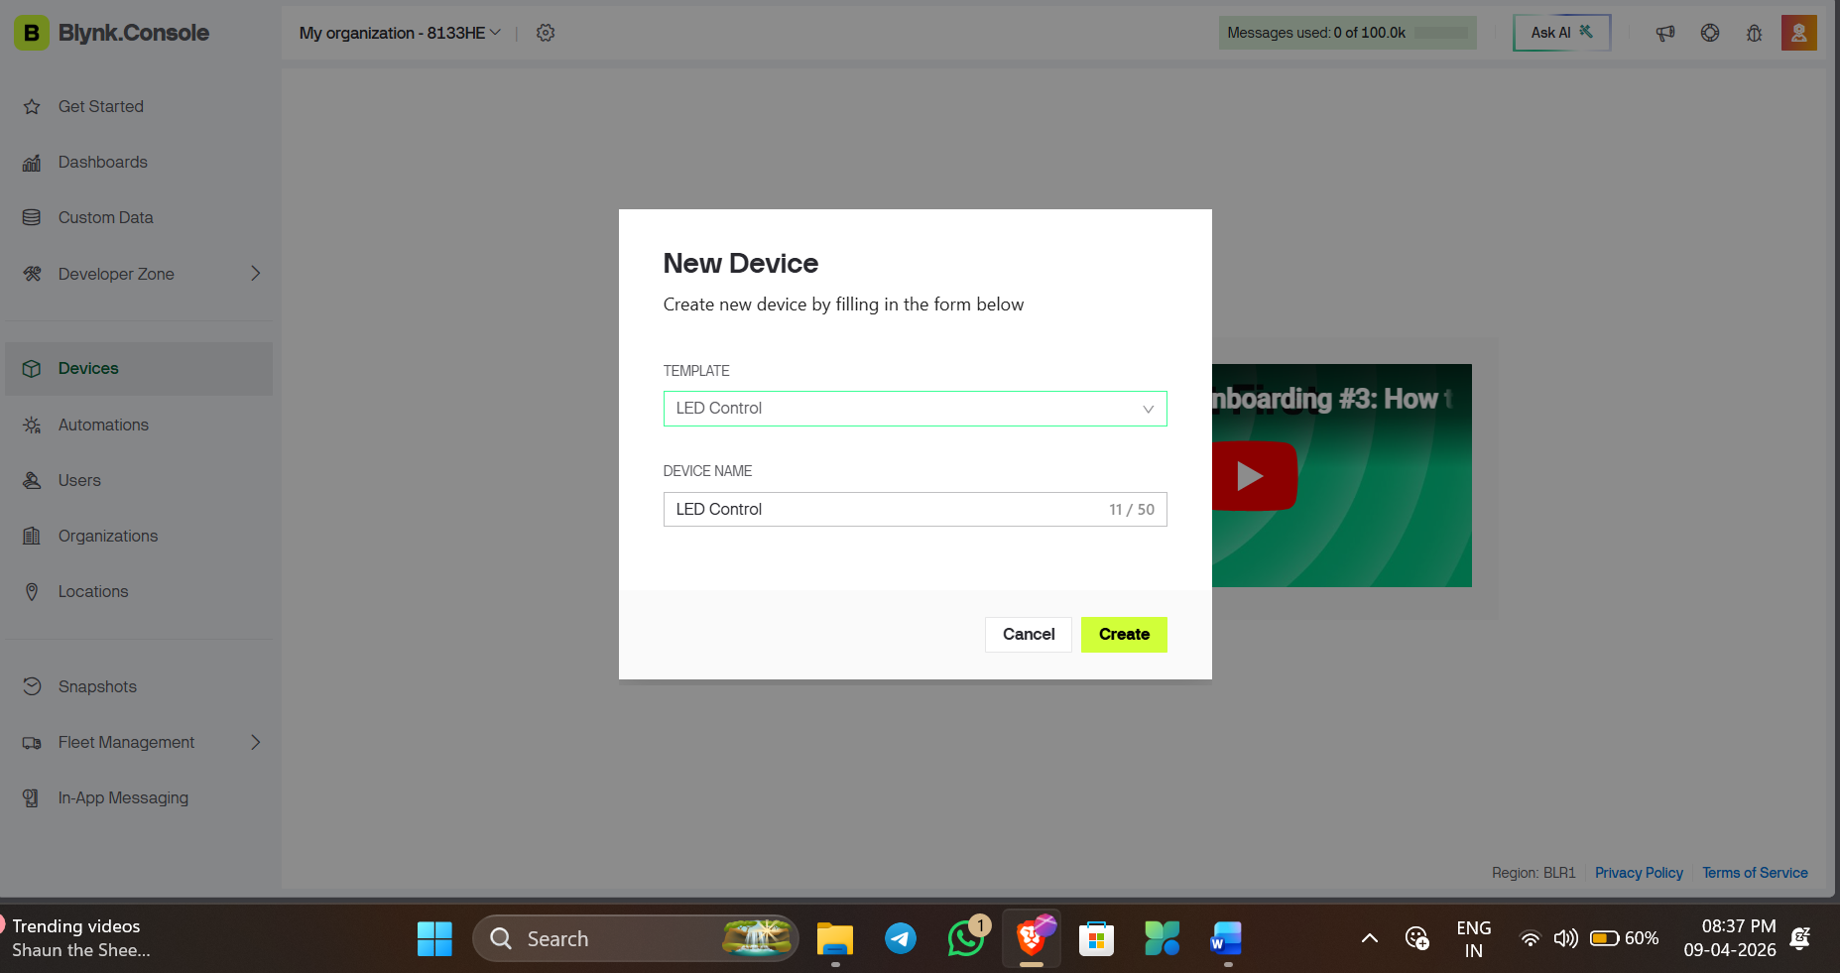
Select “Create”
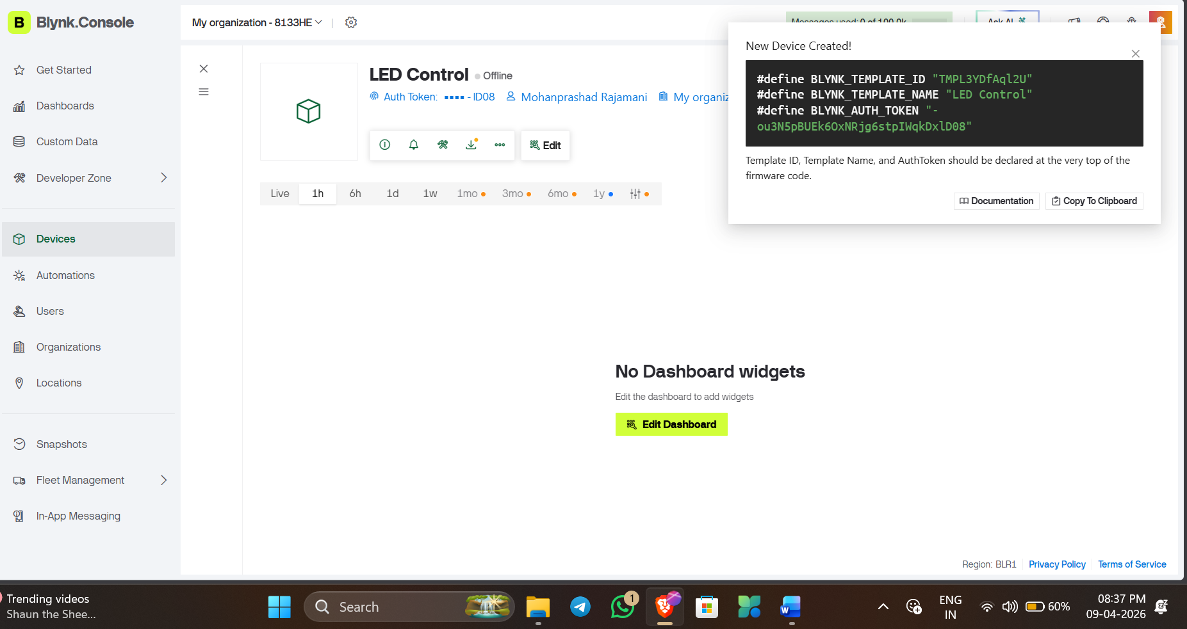
Now you can see a device is created and Api is created For your IoT device Copy this and use this on your code
- Then Select “Edit Dashboard”
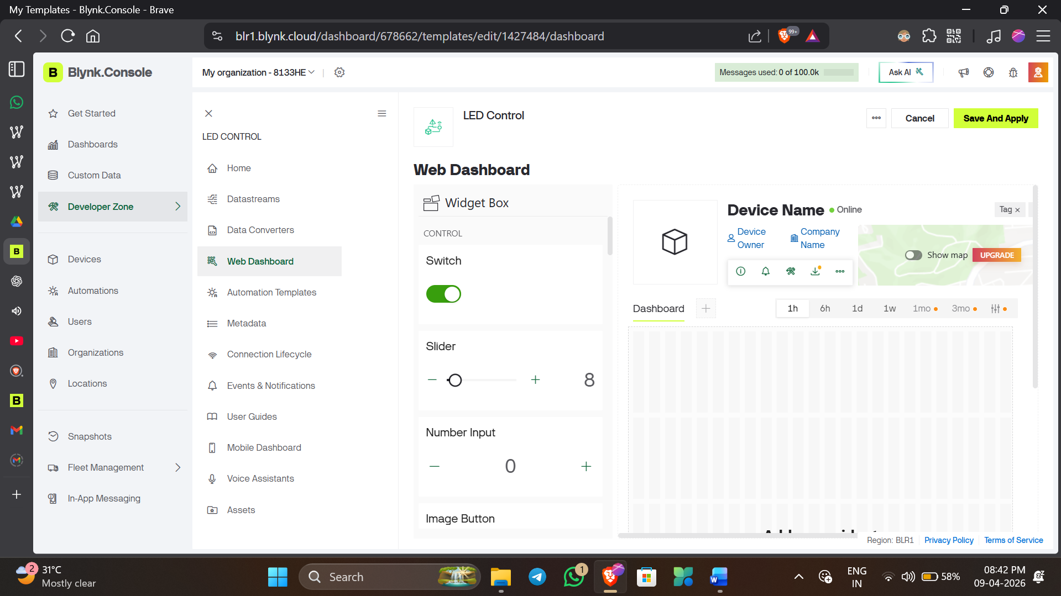
- Drag “Switch” button to Dashboard
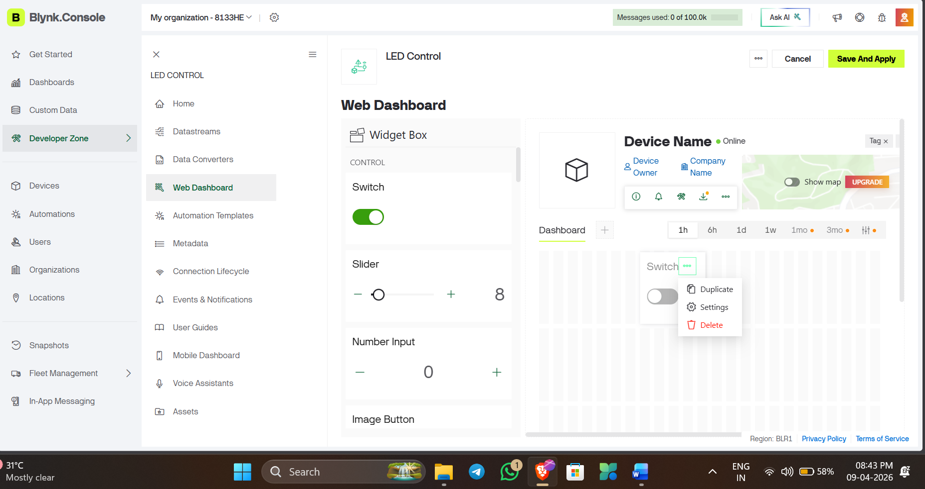
- Select “Settings”
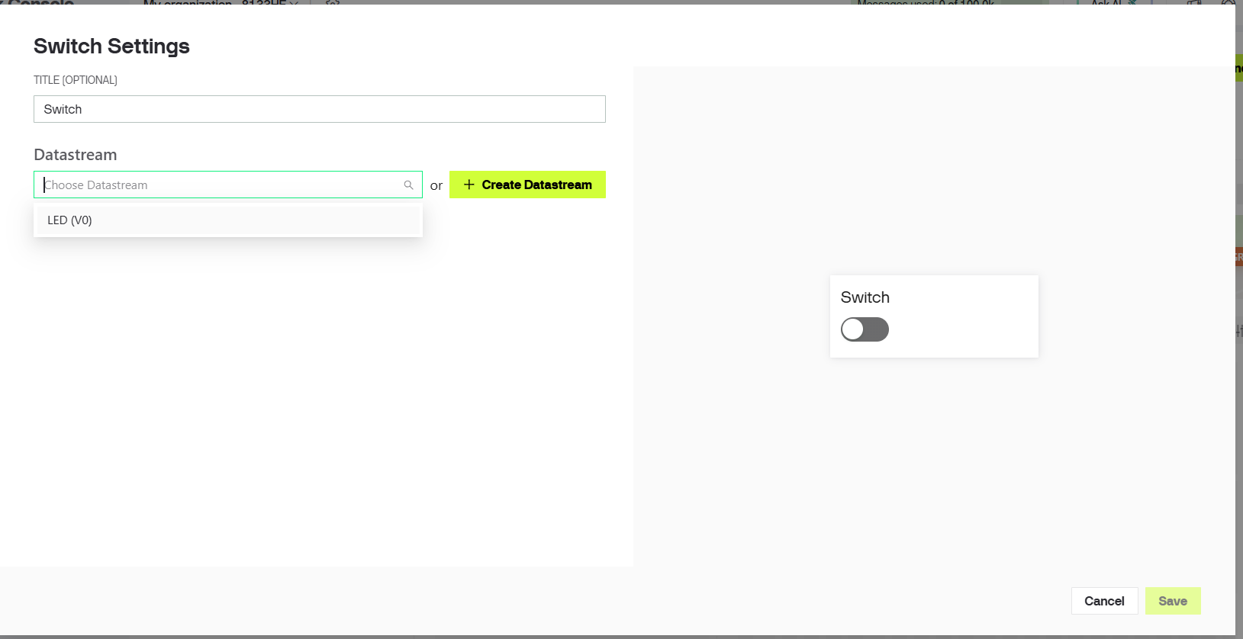
- Select Led (V0) , which we configure already
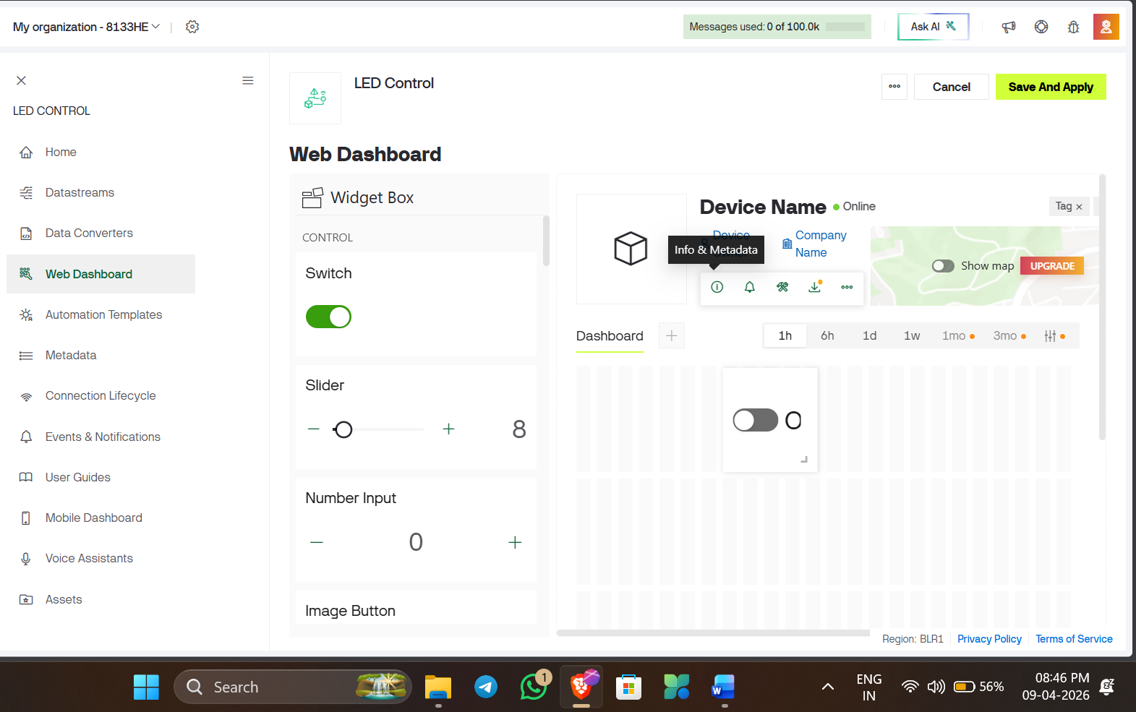
- Finally select “Save And Apply ”
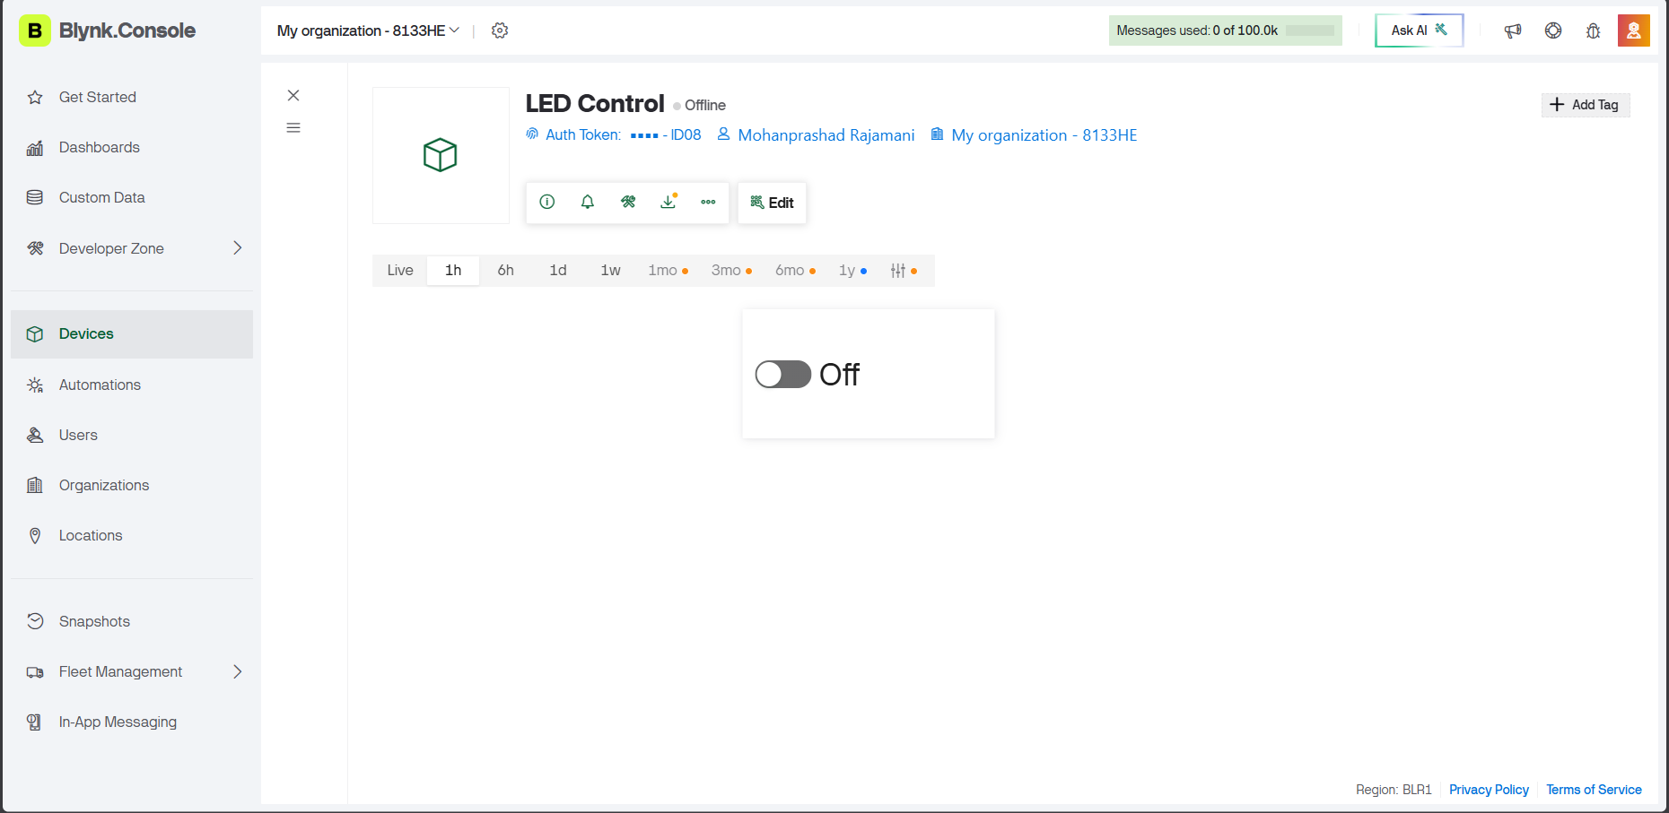

Step 6: Arduino Programming
- Open Arduino IDE
- Install required libraries:
  - Blynk
  - WiFi (ESP32)
ESP32 Configuration in Arduino IDE

✅ Step 1: Open Arduino IDE
- Open Arduino IDE on your laptop

✅ Step 2: Add ESP32 Board URL
- Go to File → Preferences
- Find “Additional Board Manager URLs”
- Paste this link:
https://dl.espressif.com/dl/package_esp32_index.json
- Click OK

✅ Step 3: Install ESP32 Boards
- Go to Tools → Board → Boards Manager
- Search: ESP32
- Install:
👉 “ESP32 by Espressif Systems”

✅ Step 4: Select ESP32 Board
Go to:
Tools → Board → ESP32 Arduino
Select:
👉 ESP32 Dev Module (most common)

✅ Step 5: Select COM Port
- Connect ESP32 via USB
- Go to:
Tools → Port
- Select correct COM port (e.g., COM3, COM4)

✅ Step 6: Install Blynk Library
- Go to Sketch → Include Library → Manage Libraries
- Search: Blynk
- Install:
👉 Blynk by Volodymyr Shymanskyy
Enter the following code:
#define BLYNK_TEMPLATE_ID "Enter you ID"
#define BLYNK_TEMPLATE_NAME "LED Control"
#define BLYNK_AUTH_TOKEN "Enter your Token"

#define BLYNK_PRINT Serial

#include <WiFi.h>
#include <BlynkSimpleEsp32.h>

// 🔹 WiFi credentials
char ssid[] = "Enter your WiFi name";
char pass[] = "Wifi Password";

int ledPin = 2;

// 🔘 Blynk button
BLYNK_WRITE(V0) {
digitalWrite(ledPin, param.asInt());
}

void setup() {
Serial.begin(115200);
pinMode(ledPin, OUTPUT);

Serial.println("Starting WiFi...");

WiFi.begin(ssid, pass);

// 🔥 Continuous connection status
while (WiFi.status() != WL_CONNECTED) {
delay(500);
Serial.print("."); // prints dots continuously
}

Serial.println("\nWiFi Connected!");
Serial.print("IP Address: ");
Serial.println(WiFi.localIP());

// Connect to Blynk
Serial.println("Connecting to Blynk...");
Blynk.config(BLYNK_AUTH_TOKEN);

while (!Blynk.connected()) {
Blynk.connect();
Serial.print("*"); // shows Blynk connecting
delay(500);
}

Serial.println("\nBlynk Connected!");
}

void loop() {
Blynk.run();
Finally upload the code: 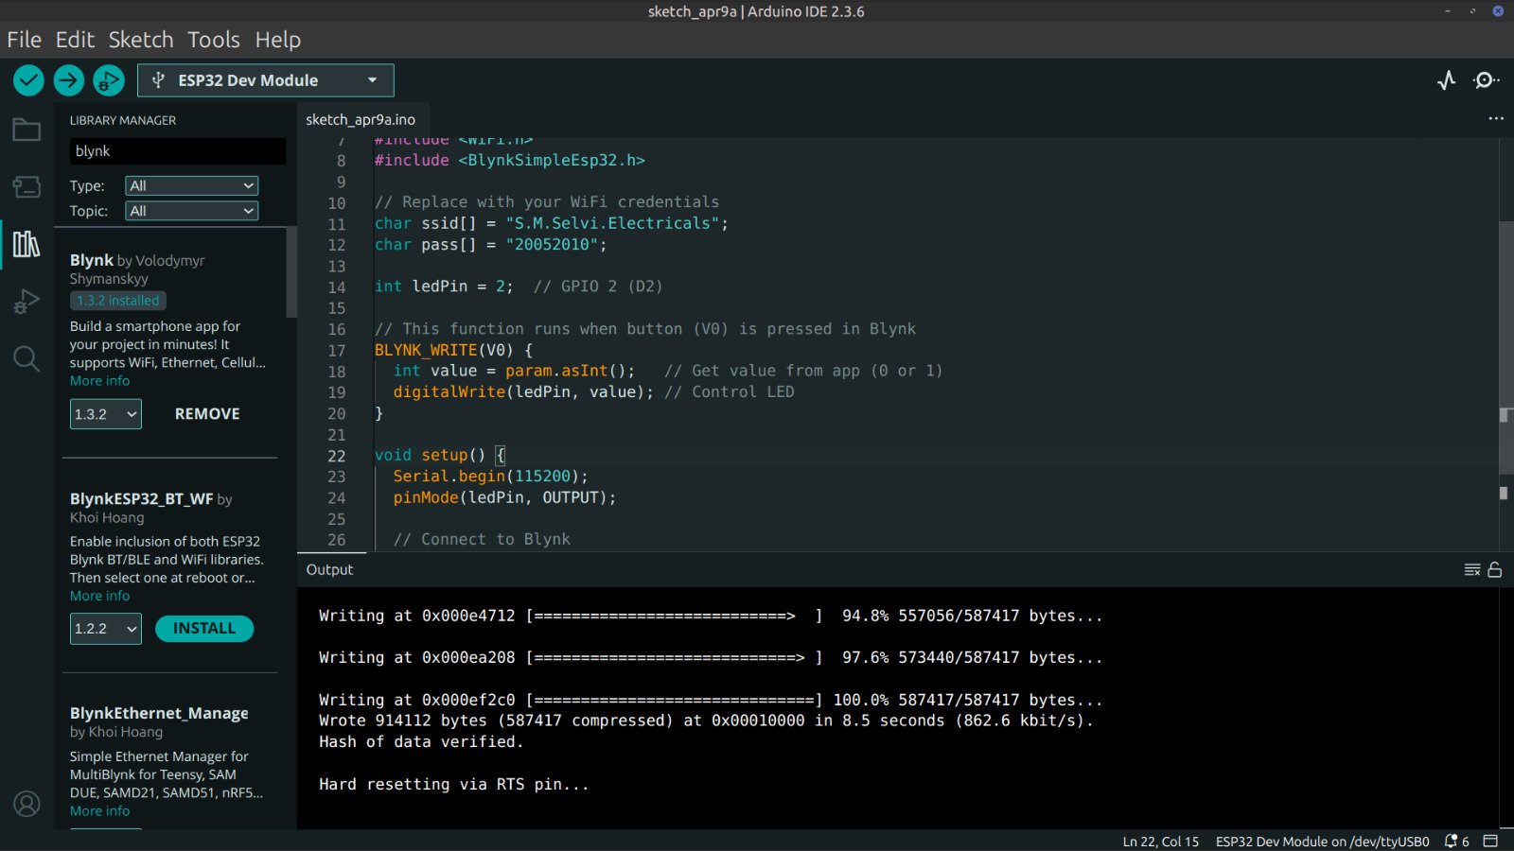

Output :
